13.47: For the situation described, 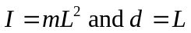 in Eq. (13.39); canceling the factor of m and one factor of L in the square root gives Eq. (13.34).

